Hook API Gateway with Lambda function

## **Method Execution** /serverless - GET - Integration Request

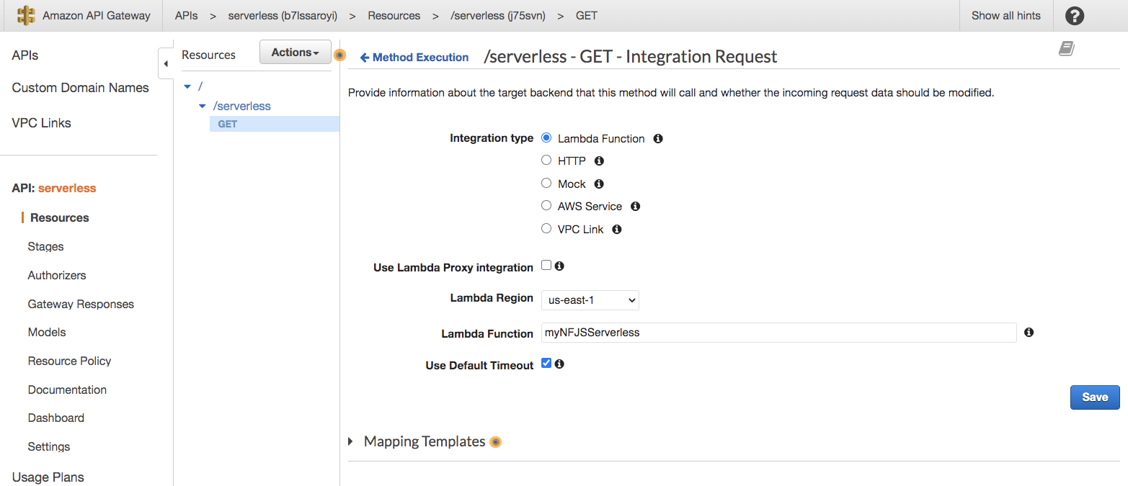

## Attach to the Lambda Function

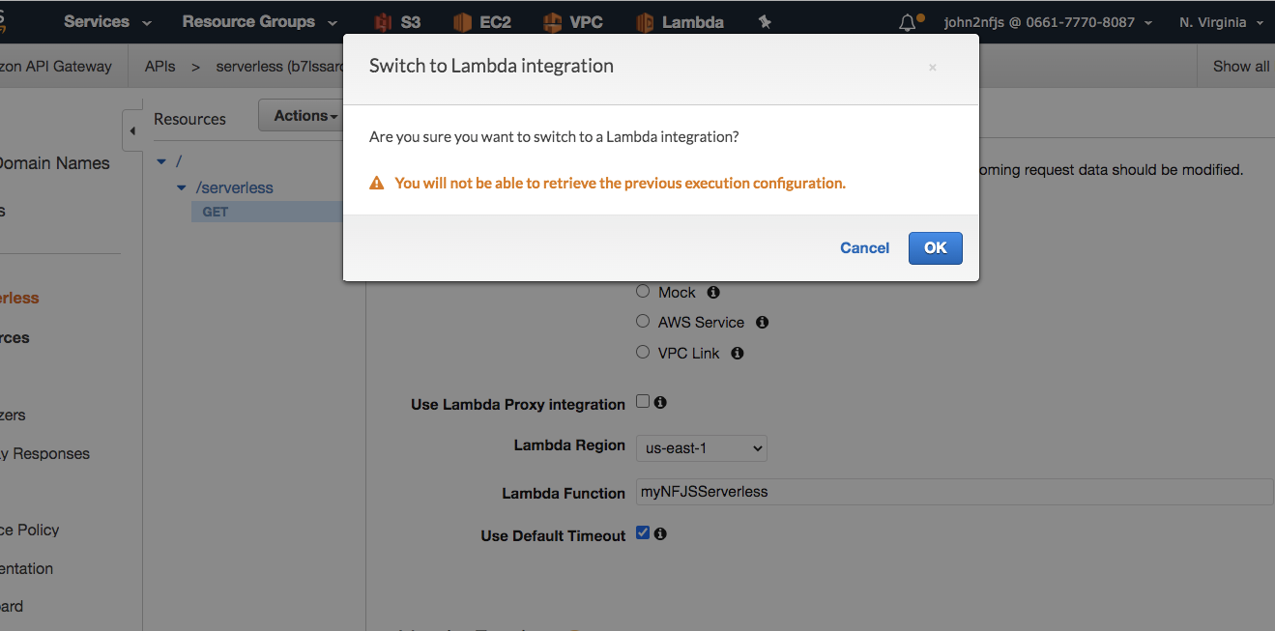

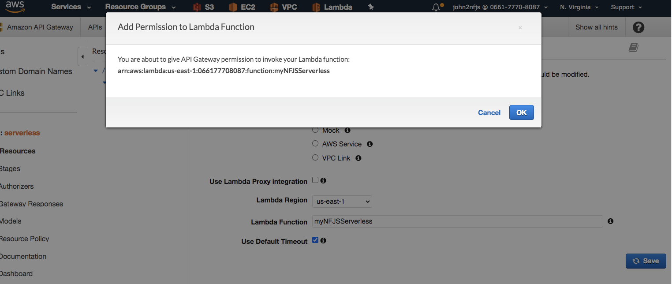

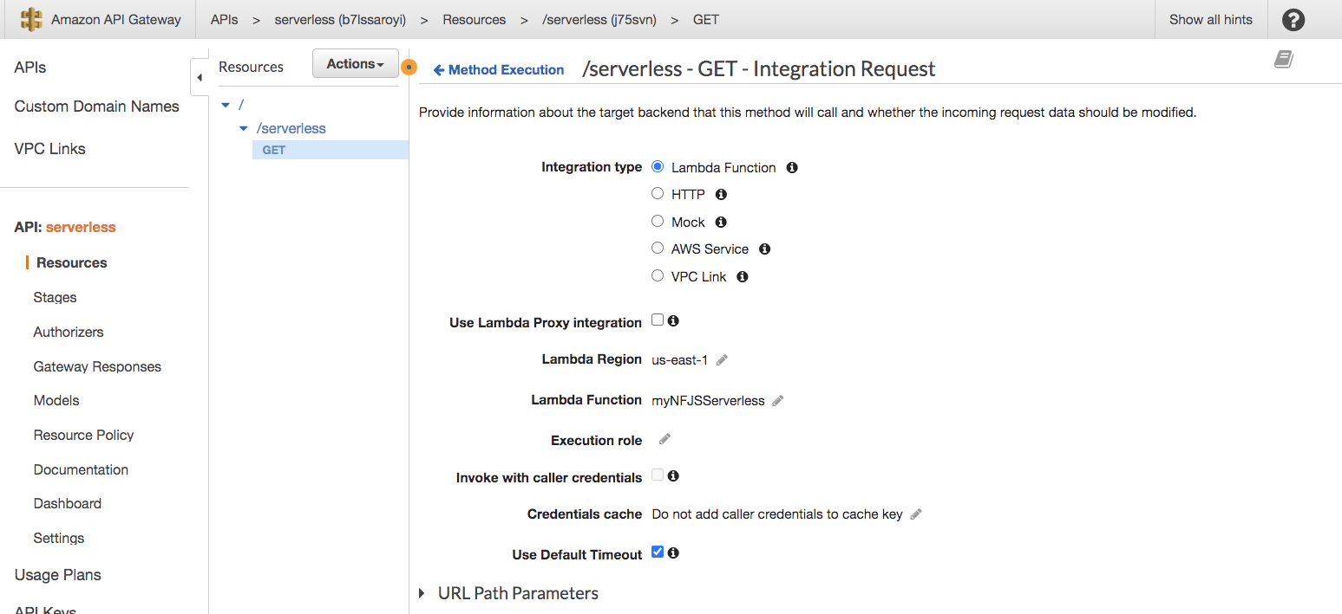

## Test the function.

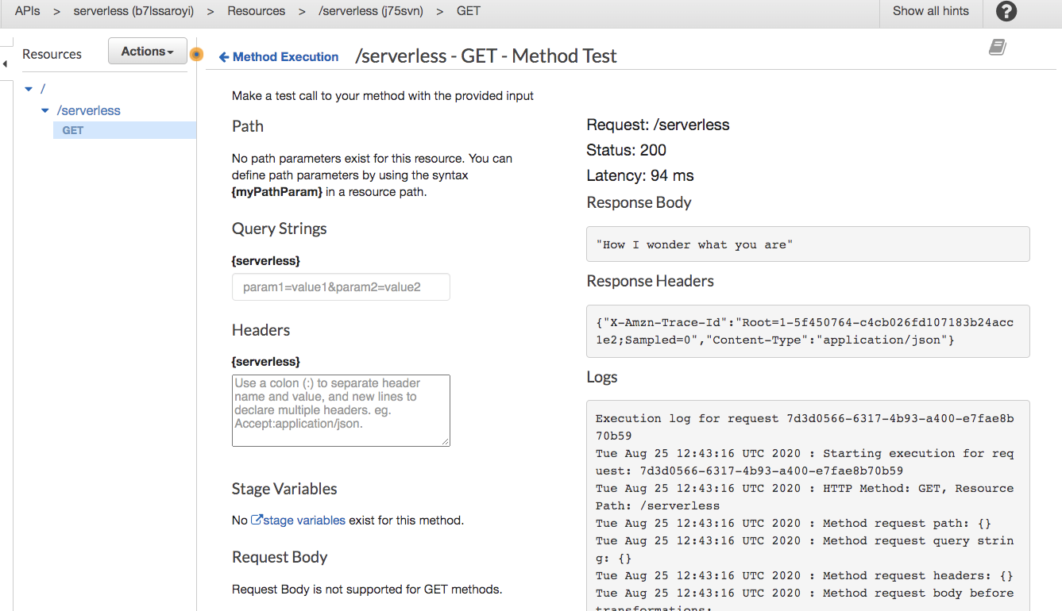

## Add the JSON wrapper in response

## **Method Execution** /serverless - GET - Integration Response

{

"greet": $input.body

}

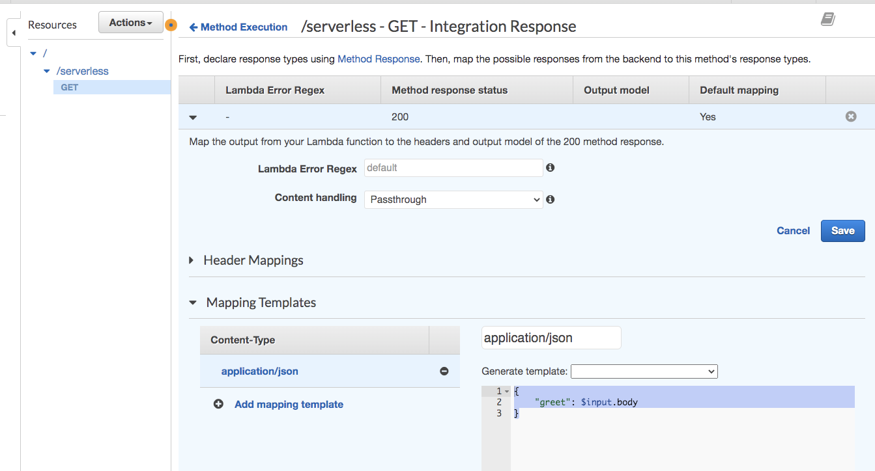

{

"Greet": $input.body

{

## Test the function again

## Try to see getting different responses.

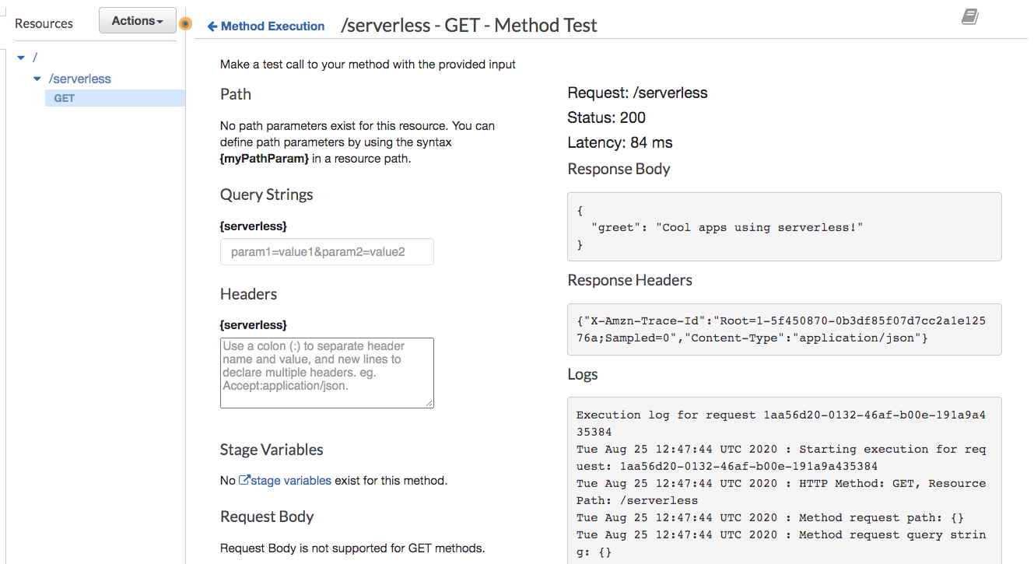

Deploy the API to stage2

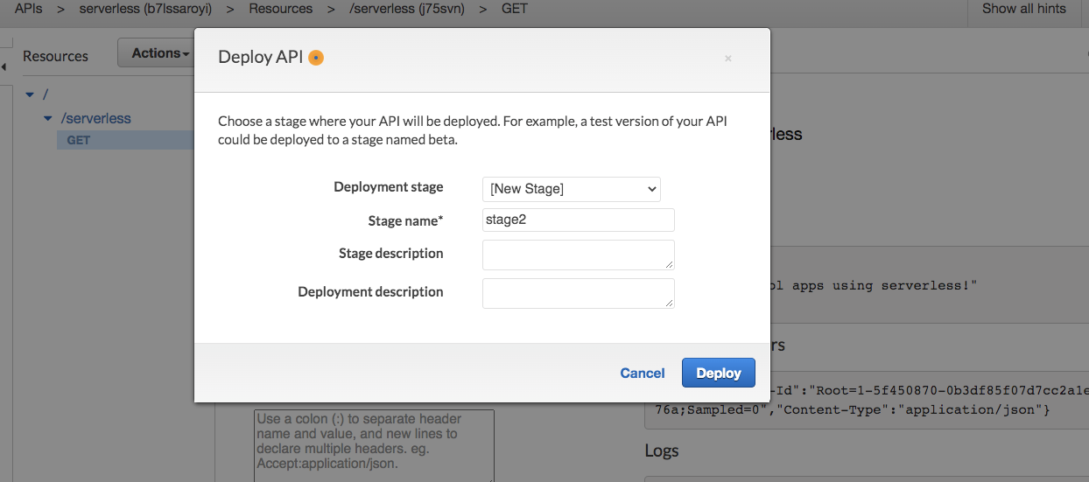

<https://b7lssaroyi.execute-api.us-east-1.amazonaws.com/stage2/serverless>

